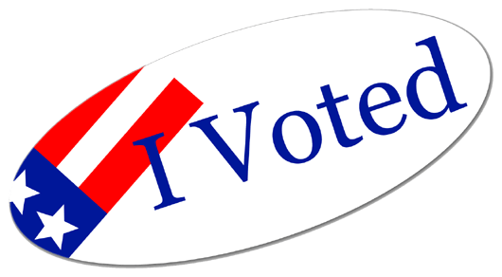

Voting is a **privilege**. Please help **encourage** participation. **Inspire** your neighbor. AL

**Golden Hill Election for District 3:**

**June 7th** , 2016 is primaries for our City Council (Chris Ward or Anthony Bernal), the day of Presidential primaries & San Diego mayor, city attorney, and Council District primaries.

**November 8th** is voting day for presidential & San Diego elections this year.

The New Year stands before us like a chapter in a book waiting to be written. We can help write that story by setting goals.

**January Special Offer-**

Visit newly opened tower at San Diego Museum of Man in our Balboa Park! FREE ticket pairs with access to the museum for first ten who call. Climb and exercise your body and mind, spectacular views inaccessible to San Diegans since 1935! Valued @ $22.50 x 2.

# Golden Hill Civic Duty

**Golden Hill utility**

**Box Art – any artists?**

Saturday, February 6th

at 9am there will be an all-day transformer box painting event by Ivy with Golden Hill Rentals. Local artists will paint boxes on the hill and turn drab utility boxes into fabulous works of art. Thank Luigi’s Pizza for divine pies at noon!!

**FREE admission to Villa Montezuma Museum**-

Located at the corner of 20th & K Streets

Saturday, January 9th, 9am-12:30pm

The Friends of the Villa Montezum would like all neighbors to see the inside of San Diego's most magnificent Villa Montezuma Museum, the gem of the Sherman Heights, built 1887.

**Golden Hill Farmers Market**-

Every Saturday from 9:30-1:30 @ B Street between 27th St. & 28th St

Get outside and enjoy fresh fruits and vegetables, flowers, bakery, cheese, sauces, dry goods, prepared foods, and specialty treats. 

January, 2016

**Thank you for continued residency!**

**Please remember to always call promptly for all repairs, suggestions, and comments (239-2278).**

Life on Golden Hill

**Polling Locations Near You:**

Chapel of Happiness

3060 Broadway Ave San Diego, CA

Mt Sinai Baptist Church

4142 Broadway  
San Diego, CA

# events On the Hill