To: All Residents
From: Golden Hill Rentals (619-301-6163) www.goldenhillrentals.com
Re: NEWSLETTER (7-13-21)

Dear Residents,

BE SAFE, TAKE CARE
We welcome summer and a glimpse of life starting up again!
It is our pleasure to serve you and insure your home is safe and sound. Please do not hesitate to call with suggestions, or problems we can solve as your housing administration. We are proud of our work with you.

LOCAL GOVERNANCE
Please stay engaged with our local representatives for any reason and use the links and numbers below:
Mayor Todd Gloria 619-236-6330 mayortoddgloria@sandiego.gov
City Council District 3 Whitburn 619-236-6633 stephenwhitburn@sandiego.gov
Steve Whitburn’s assistant, Ryan 619-510-6881 rdarsey@sandiego.gov
Homeless? call Outreach Team 619-446-1010 hot@pd.sandiego.gov
Graffiti, encampments, etc. report: https://www.sandiego.gov/get-it-done

Find out what Whitburn or others are doing for Golden Hill at our next Town Hall meeting. Anyone wish to help organize it? Let’s get more than lip service from our GH representatives!

TRANSFORMER BOX PAINTING
Plans are being made for another neighborhood project to paint some of the prominently placed electrical transformers. The “go ahead” has been given to move forward. If you are an artist (or know any) and have an interest in painting one of the boxes, please submit some visual examples.

BREAKFAST BLOCK SD
Another great volunteer opportunity is https://www.breakfastblocksd.org. See the good work they are doing blocks away.

“Breakfast Block SD is a black female founded community run mutual aid. We are 100% donation based and we collect and redistribute food, money, vital supplies, and resources to our unsheltered community members in San Diego. We believe that everyone is deserving of respect and the basic necessities to survive. We do not work with law enforcement or ICE. We never have and never will. We stand in solidarity with all who are fighting against oppression as we push for justice and human rights for all. We are a judgement free zone, and our mutual aid is guided by love, light, and positivity. https://www.breakfastblocksd.org”

FIRE SEASON IS HERE
Please make note how to use a fire extinguisher in the event you ever need one.
Fire extinguishers are prominently placed on each property. Know where yours is! If you need an extra let us know, ASAP. Below is a quick way to remember how to use an extinguisher.

P - Pull pin
A - Aim at base
S - Squeeze handle
S - Sweep side to side at base

RECYCLING
Please break down cardboard boxes before putting them in the recycling bins. With such a high volume of recycling, we need to maximize bin space. If the bins are too full for your broken-down boxes, just slide them in between the bins and we will collect them. In addition, do not put any food items or containers that have food still on them (this includes the greasy portion of pizza boxes) in recycle bins, this contaminates the other items.

SUMMER OF SOUL
We encourage everyone to watch the powerful documentary “Summer of Soul”. You can see it in theaters as well as on Hulu, tremendous: https://www.youtube.com/watch?v=slFiJpAxZyQ

Here is a quick read about scooters and other similar self-propelled electric vehicles we see downtown and in surrounding areas: https://mcculoughla.com/news

NEW FACES
We have a new face joining our Golden Hill team. Darci will be joining Alesia in helping with the day-to-day operations. You may see her at the properties or hear from her in a phone call or text. We are excited to have her.

Thank you for your continued residency! www.goldenhillrentals.com (619-301-6163)
____________________________________________________________________________________
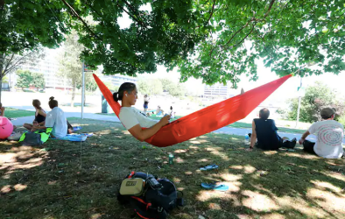 |  | A cool idea for low-income urban areas hard hit by warming climate: more trees  washingtonpost.com
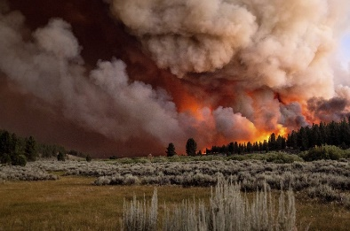 | California hit by record-breaking fire destruction: ‘Climate change is real, it’s bad’  latimes.com

